ISSN 1330-3651
UDC/UDK

EXPLOITATION OF THE HYDROKINETIC POTENTIAL OF RIVERS BY COMBINING THE TRADITIONAL WATER WHEEL AND THE DARRIEUS TURBINE

Vlado Halusek, Damir Šljivac, Lajos Jozsa

The kinetic energy of river currents is weakly researched for the possibility of production of electrical energy. Thus there are very few new suggestions for the exploitation of this energy form. This paper shows a method of exploiting the hydrokinetic energy of river currents created by combining the traditional water wheel and the Darrieus turbine. The water wheel is used due to its historic and traditional meaning and the Darrieus turbine is added due to the increase of the overall power of such a facility. The choice of the most favorable location for the micro-hydroelectric power plants of this type is done based on the data received by measuring the hydrological characteristics of the watercourse using the ADCP (Acoustic Doppler Current Profiler) device.

Key words: ADCP method, Darrieus turbine, hydrokinetic energy, the River Drava, water wheel

Iskorištavanje hidrokinetičkog potencijala rijeka kombinacijom tradicionalnog vodnog kola i Darrieus turbine

Kinetička energija riječnih struja je slabo istražena za mogućnost proizvodnje električne energije. Zbog toga ima malo novih prijedloga za iskorištavanje tog oblika energije. Ovdje se prikazuje metoda iskorištavanja hidrokinetičke energije riječne struje koja je nastala kombinacijom tradicionalnog vodnog kola i Darrieus turbine. Vodno kolo se koristi zbog povijesno-turističkog značaja, a Darrieus turbina se dodaje zbog povećanja ukupne snage takvog postrojenja. Odabir najpovoljnije lokacije za mikro hidroelektranu tog tipa vrši se na temelju podataka dobivenih mjerenjem hidroloških karakteristika vodotoka pomoću ADCP (Acoustic Doppler Current Profiler) uređaja.

Ključne riječi: ADCP metoda, Darrieus turbina, hidrokinetička energija, rijeka Drava, vodno kolo

1
Introduction

In the world hydrokinetic energy is used in various ways. But all of them are mostly connected to great hydroenergy power plants at sea or ocean where the energy of the waves, energy of the tide and the energy of the currents is used [1,2]. In modern times not much is said about the exploitation of the hydrokinetic energy of rivers for obtaining electrical energy with the help of traditional water wheels, even though such forms of energy have been used as drive for other machines (to drive mills, saw-mills, for irrigation, etc.). Water mills used kinetic energy of river currents which is proportional to the speed squared of the river current. So they have been mostly built as floating (pontoon) and anchored objects, at a 5 m distance from the river-bank, where the speed of the river is greater. Aside from that, the owners have carefully chosen the locations based on experience. The locations were usually near the right side of the river bed (seen from the spring to the estuary), in places where the river bed turns left because this is where the main river current, which is in the middle of the river bed, comes nearer to the river-bank and enables greater power to the mills. This can be seen in Figure 1 which depicts one of the last mills on the River Drava, which has been active until the beginning of the 1970s.

Figure 1 Mill on the River Drava near Podravske Sesvete (source: the private archive of Kovačić Željko from Podravske Sesvete)
Slika 1. Mlin na Dravi kod Podravskih Sesveta (izvor: privatni arhiv Kovačić Željka iz Podravskih Sesveta)

All known mills on the River Drava used the water wheel with a downward flow as a turbine. The devices for energy transfer and mill stones were usually placed at the anchored pontoon with the water wheel so that the energy was directly transferred from the water wheel to a lesser water wheel which was used as a multiplier of the number of turns. From the lesser water wheel the energy was transferred to two mill stones which grinded the wheat. There is an alternative to the transfer of energy from the water wheel to the grinding plant, which was used in a more expensive but much more efficient process. In such constructions the water wheel was at the pontoon and the transfer of mechanical energy was conducted via wire-rope to the mill which was on the river-bank.
The water wheels are developed and perfected even today [3], but this is done mainly to exploit the gravitational potential energy in small and micro-hydroenergy power plants which are operating or are being constructed [4]. Aside from traditional water wheel there are also other forms of turbines meant for the exploitation of the hydrokinetic energy such as the vertical Darrieus rotor or the Darrieus turbine [5] (Figure 2).
Figure 2 The vertical Darrieus rotor
Slika 2. Okomiti Darrieus rotor

The Darrieus turbine is meant for the exploitation of the wind energy [6, 7], and the wave energy [8, 9], and the river current energy [5], the exploitation of the kinetic energy of fluids [10]. So the power of the turbine is determined from the formulae:

$P=η\frac{1}{2} v^{3}A$ (1)

where P is the power of the water wheel in kW, η is efficiency, $v$ is the speed of the watercourse at a chosen location and A is the area of the paddles of the water wheel.
For the exploitation of the hydrokinetic energy precise hydrological measurements are required, which, in today’s world, are performed by the ADCP (Acoustic Doppler Current Profiler) method [11]. Considering the fact that this method is increasingly used in our country [12, 13], there are possibilities for its adjustment for the determination of the hydrokinetic potential of some watercourse in a non-conventional way, as proposed in this paper. The measuring of the water flow in Croatia is performed by the State Weather Bureau [14] along with a company called “Hrvatske vode” [15].

2
The model of optimizing the locations of the combined hydrokinetic power plant by using the ADCP method

ADCP is a device which, with the help of emission of acoustic impulses, and based on the Doppler effect [16], determines the flow section (profile) of the observed watercourse as well as the speed field division (speed profiles) across that flow section, based on which the flow of the watercourse is determined [13]. This system is still under development, yet it is already far more efficient and precise than measuring the flow with the moving boat method, which is still in use. While determining the speed of the water flow with the ADCP, the sound waves in the ultrasound area are used. The usual frequencies are larger than 30000 Hz, and devices based on the 300000 Hz, 600000 Hz or 1200000 Hz frequencies are mostly used. Measuring the flow speed with the help of the ADCP is based on the physical principle of the apparent frequency change, as explained by Christian Johann Doppler [16]. The apparent frequency change of the determined sound source appears when the source moves relatively according to some observer. When measuring the water flow speed, the ADCP emits an acoustic impulse into the water pillar, through its receiver. The receiver simultaneously records the returning echo of the signal which reflects off the particles suspended in water which are always present in a larger or smaller number. The reflected signal is first analyzed and compared with the emitted signal by applying the auto-correlation functions and algorithms. The reflected signal must have the form similar to the originally emitted one. After that, the Doppler shift is calculated, out of which the speed of the watercourse current is determined, through the formulae:

$f_{D}=2 f_{S} \frac{v_{r}}{c} \cos{θ}$ (2)

where f_{D} is the Doppler frequency shift, f_{S} is the sound frequency from a stable source (from the receiver), v_{r} is the relative speed of movement between the sound source and the receiver, c is the sound speed and θ is the angle between vectors of the relative speed of the boat and the direction of the wave trajectory.
The ADCP is attached to the boat so that it is immersed in the water and pointed toward the bottom of the watercourse. In the device’s case four acoustic receivers, angled approximately 25° in relation to the device's vertical axis, are most commonly placed. Each receiver generates its own independent ultrasonic beam and determines the speed of the watercourse independently. In this manner the device completely covers the space beneath it. In the illustrated example the ADCP device has been placed on a 50 cm depth, below the surface of the river current.
In order to determine the most suitable micro-locations for using the hydrokinetic energy in a way proposed in this paper it is necessary to determine the local maximums of partial speeds and the depth of the transversal section of the watercourse. A concrete example was made based on the measurements of the water flow of the River Drava, done by the ADCP method, at the measuring station Donji Miholjac. The graphical depiction of the measurements, adapted for this paper, can be found in Figure 3. Figure 3 is used exclusively to determine the place with the largest
depths. For this paper only the speeds at 50 cm depth are relevant, and those speeds are specially given by the State Weather Bureau. The results of the measurements are read from the computer at the State Weather Bureau (Table 1), and then they were transformed into a graphical depiction of the dependency of partial speeds and depths to the distance from the right river-bank for the mean value of the flow (Figure 4).
For the use of hydrokinetic energy with the method of combining the water wheel and the Darrieus turbine, the data of the locations with maximum speeds and depths is needed. Such places can be determined with the help of Figure 4 so that from the diagram of the middle flow the local maximums of partial speeds and the local maximums of partial depths can be read. According to the local maximums of partial speeds, the most favorable locations for the floating hydroelectric power plants are at 125 m and 145 m from the right river-bank. By observing the local maximums of partial depths, the most favorable locations are at 145 m and 155 m from the right river-bank. Taking this into consideration, the most favorable location is at 145 m from the right river-bank, where the speed is 1,041 m/s, and the depths is 3,41 m.

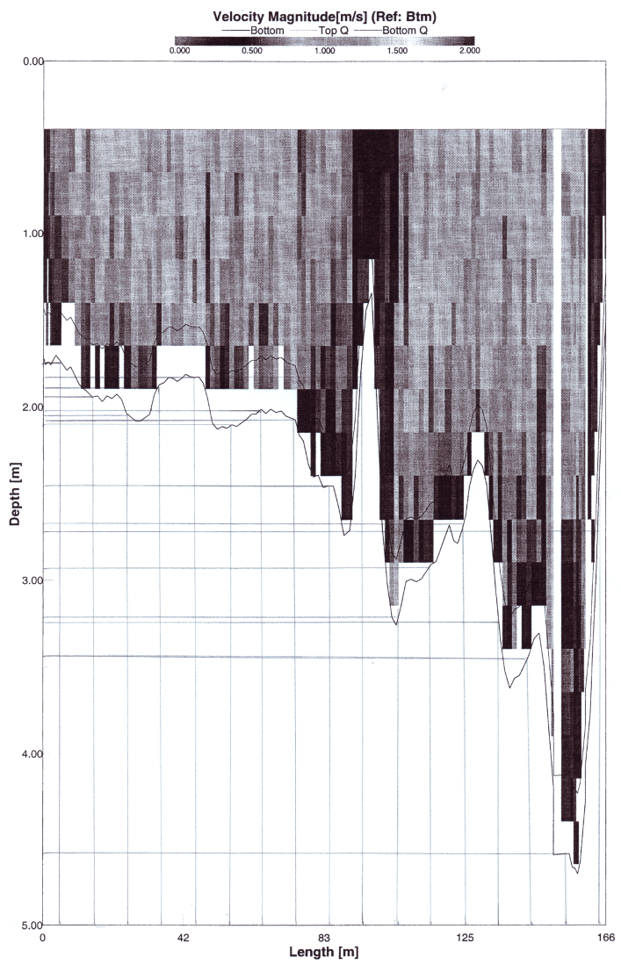
Figure 3 The dependency of partial speeds of the transversal section of the River Drava with regard to depth and distance from the right river-bank for a mean water-level, measuring station Donji Miholjac
Slika 3. Ovisnost parcijalnih brzina poprečnog presjeka vodotoka Drave o dubini i udaljenosti od desne obale za srednji vodostaj, mjerna stanica Donji Miholjac

The advantage of the ADCP method is that favorable micro-locations can be very easily and quickly determined. Already, one bisection or one measuring could give practically useable results. By analyzing the graphical depiction it is necessary to mention that the measuring with the ADCP method begins and ends at a distance of 5 m from the river-bank due to the length of the boat. But the data collected for distances nearer to the river-bank have no significant impact because the water nearer to the river-bank has very small speeds. It is also significant, for further processing, that the measured speeds are related to the depth of 50 cm from the surface of the water.
Table 1 The hydrological characteristics of the River Drava at Donji Miholjac, obtained by the ADCP method, measured at 50 cm depth
Tablica 1. Hidrološke karakteristike rijeke Drave kod Donjeg Miholjca dobivene ADCP metodom, mjereno na dubini 50 cm

Distance from the right bank, m |  | Speed, m/s |  |  |  | Depth for middle flow, m
 |  | Low flow | Middle flow |  | High flow
5 |  | 0,438 | 0,726 |  | 0,898 | 1,72
15 |  | 0,727 | 0,834 |  | 1,092 | 1,82
25 |  | 0,630 | 0,829 |  | 1,148 | 2,04
35 |  | 0,687 | 0,920 |  | 0,976 | 1,72
45 |  | 0,787 | 0,858 |  | 1,115 | 1,72
55 |  | 0,763 | 0,891 |  | 0,888 | 2,12
65 |  | 0,691 | 0,914 |  | 1,066 | 2,02
75 |  | 0,759 | 0,965 |  | 0,789 | 2,01
85 |  | 0,642 | 0,868 |  | 1,083 | 2,47
95 |  | 0,617 | 0,952 |  | 0,954 | 1,67
115 |  | 0,687 | 0,486 |  | 1,164 | 2,96
125 |  | 0,726 | 1,029 |  | 1,199 | 2,59
135 |  | 0,752 | 0,866 |  | 1,131 | 2,78
145 |  | 0,659 | 1,041 |  | 1,073 | 3,41
155 |  | 0,726 | 0,840 |  | 1,085 | 4,59
165 |  | 0,644 | 0,656 |  | 0,873 | 3,18
Accompanying data
Flow, m³/s | 260 |  |  | 480 | 650 | 480
Water level, cm | - 66 |  |  | 52 | 134 | 52
Date | 7. 02. 2008. |  |  | 11. 10. 2007. | 5. 06. 2008. | 11. 10. 2007.

Figure 4 The dependency of partial speeds and depths of the transversal section of the River Drava watercourse with regard to the distance from the right river-bank for a mean water-level, measuring station Donji Miholjac
Slika 4. Ovisnost parcijalnih brzina i dubina poprečnog presjeka vodotoka Drave o udaljenosti od desne obale za srednji vodostaj, mjerna stanica Donji Miholjac
3
The method of exploiting the hydrokinetic energy of river currents by combining the traditional water wheel and the Darrieus turbine

The hydrokinetic energy of river currents has been traditionally exploited with the help of the water wheel. Considering that the wheel has a relatively small power for today’s standards, people have gradually moved on to other forms of energy. In recent years, however, non-conventional ways of using energy have gained more emphasis - thus creating the proposal for the use of hydrokinetic energy of river currents by combining the traditional water wheel and the Darrieus turbine. The water wheel is used due to its historic and traditional meaning and adding one or two Darrieus turbines is due to the increase of the overall power. This combination is considered so that on the outside the traditional appearance of this hydroenergy object is kept completely, as shown on the copy of a part of a design for a small village power plant from 1920 (Figure 5).

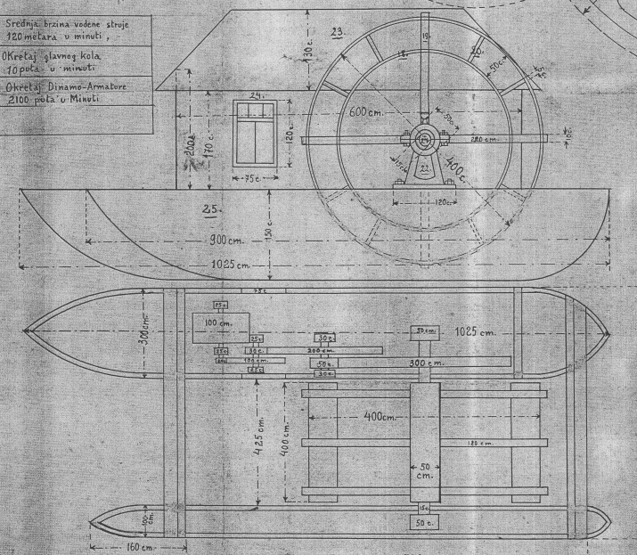

Figure 5 A part of the design of a floating hydroenergy power plant from 1920, courtesy of Janči Đuro from Đurđevac
Slika 5. Dio nacrta ploveće hidroelektrane iz 1920. godine, ustupio Janči Đuro iz Đurđevca

It is planned that the Darrieus turbines are submerged into the water below the supporting section (pontoon) so that they are not visible from the outside. According to Figure 5, a plan has been made to set a Darrieus turbine with a diameter of 0,9 m and 0,6 m height. Three Darrieus turbines are placed beneath the front section of the pontoon so that one turbine (D₁) is placed beneath the narrower section, and the other two (D₂ and D₃) are parallel beneath the wider section of the pontoon (Figure 6). Between the narrower and the wider section of the pontoon is the water wheel. Considering the length of the pontoon which is 10 m, three turbines are placed in the same manner beneath the back section of the pontoon. This means that 6 Darrieus turbines are placed beneath the entire pontoon.
Technically useable power P_{T} of such a system of turbines is gotten by adding the strengths of individual turbines, like this:

$P_{T}=P_{W}+\sum_{i=1}^{n}{P_{Di}}$ (3)

where P_{W} is the technically useable power of the water wheel, P_{Di} is the technically useable power of the i-th Darrieus turbine, and n is the number of the Darrieus turbines.

Figure 6 The placement of front Darrieus turbines and the water wheel in a combined hydrokinetic power plant
Slika 6. Raspored prednjih Darrieus turbina i vodnog kola u kombiniranoj hidrokinetičkoj elektrani

Considering that the measuring station Donji Miholjac on the River Drava is the most suitable micro-location for the placement of a combined hydrokinetic power plant at 145 m, where the mean speed is 1,041 m/s, for determining the overall technically usable strength of this object we consider the speed of 1 m/s. The efficiency of the Darrieus according to [8,9] is η = 0,45. According to [5], for the mean speed of the river current v = 1 m/s, and the ratio of diameter d = 0,9 m and the rotor height h = 0,6 m, which is d : h = 1,5 : 1, technically usable power of one turbine is P_{Di} = 1,45 kW.
The traditional water wheel with a downward flow has a efficiency of about 0,2 [10], but a significantly larger surface of paddles. The usual length of the water wheel was equal to the diameter, which was four meters. If the length of the paddle is 0,5 m, it means that the surface of the paddles is A = 2 m² . If the same speed is used as was for the Darrieus turbine, which is v = 1 m/s this means that the technically usable power of the traditional turbine is P = 0,2 kW for the given conditions. With a more perfected type of the water wheel, which has the paddles placed tangentially [11], the efficiency is doubled as with the Poncelet design and is approximately 40%. In this case, the output power for the same conditions is P = 0,4 kW. Taking into account 6 Darrieus turbines have been considered for this hydrokinetic power plant, according to (3) and previous calculations of individual turbines, a result is given that says the overall technically usable power of all turbines for the chosen location is 9,11 kW.
Herein described, hydroelectric power plant’s design requires connection power lines and special protection systems, regulation unit and system control and data acquisition at the connection point to low voltage or medium-voltage electricity distribution network (including power transformers). Protection system design is very similar for all renewable energy sources like for wind power plant, described in [17].

4
Conclusion

Technically usable power of one hydrokinetic power plant made by combining the water wheel and a Darrieus turbine at a location chosen with the ADCP method is 9,11 kW. This is not a large power when compared to the usual power of small hydroelectric power plant with a range from 500 kW – 5 MW in our country or up to 10 MW in the countries of European Union. In spite of all this, these facts cannot be neglected in such conditions where an increasing energy crisis is predicted. Using this energy may be a contribution to the fulfillment of obligations for increasing energy production from renewable sources. Considering that this is the power of only one object of that kind, which means that the exploitation of hydrokinetic energy could be done in a series of locations. Aside from that, it is logical that there are transversal sections of smaller areas which necessarily means greater speeds in order to keep the flow at the same value. The existence of such places has been confirmed in praxis, because water mills were built only on certain locations in the past. The ADCP method of measuring partial speeds of the watercourse is suitable for determining the micro-locations for “Run-of-the-river” hydrokinetic power plants, because after the statistical analysis of received data and its graphical depiction, the local maximums of partial speeds and depths of the transversal section of the watercourse can be very precisely determined, which means determining the most favorable micro-locations for “Run-of-the-water” hydroelectric power plants.

4
References

- Ciocci, L.C. Keeping water in the U.S. mix. // Power and Energy Magazine. 6, 4(2008), pp. 36-39.
- New Technology Hydropower. National Hydropower Association. 2008. URL: http://www.hydro.org/. (10. 06. 2011.).
- Aschenbrenner, F. Innovation on Traditional Waterwheels for Renewable Energy. // Power Electronics and Motion Control Conference. Portoroz, Slovenia, 2006, pp. 1625-1630.
- Mohibullah, M.; Radzi, A.M.; Hakim, M.I.A. Basic design aspects of micro hydro power plant and its potential development in Malaysia. // Power and Energy Conference. Kuala Lumpur, Malaysia, 2004, pp. 220-223.
- Khan, M.J.; Iqbal, M.T.; Quaicoe, J.E. Design Considerations of a Straight Bladed Darrieus Rotor for River Current Turbines. // Industrial Electronics, IEEE ISIE 2006. Montreal, Quebec, Canada, 2006, pp. 1750-1755.
- Paraschivoiu, I. Wind Turbine Design: with Emphasis on Darrieus Concept. Canada: Polytechnic International Press, 2002.
- Darrieus wind turbine analysis. URL: http://windturbine-analysis.com/index.htm/. (10. 06. 2011.).
- Kiho, S.; Suzuki, K.; Shiono, M. Study on the power generation from tidal currents by darrieus turbine. // Proc. International Offshore and Polar Engineering Conference. Vol. 1, 1996, pp. 97-102.
- Kirke, B. Developments in ducted water current turbines. // Tidal paper 16-08-03, 1. URL: http://www.cyberiad.n5et/tide.htm/. (10. 06. 2011.).
- Crnković, D.; Šljivac, D.; Stojkov, M. Influence of wind power plants on power system operation – Part one: Wind power plant operation and network connection criteria. Tehnički vjesnik, 17, 1(2010), pp. 101-108.
- Trenaman, N.; Marsden, R. Horizontal acoustic Doppler current profile instrument development and applications. // Proceedings of the IEEE/OES Seventh Working Conference on Current Measurement Technology, 2003, pp. 7-11.
- Terek, B. Mjerenje protoka otvorenih vodotoka uporabom ADCP-a. // Hrvatska vodoprivreda. 12, 125-126(2003), str. 10-14.
- Halusek, V.; Šljivac, D.; Jozsa, L. Determining the Hydrokinetic Potentials of the Transversal Section of the Watercourse Via the ADCP Method and Dimensioning of Hydrokinetic Power Plant. // Strojarstvo, 52, 6(2010), pp. 673-680.
- URL: http://www.dhmz.hr/, (31. 08. 2011.).
- URL: http://www.bistra.hr/, (31. 08. 2011.).
- Halliday, D.; Resnick, R.; Walker, J. Fundamentals of Physics. 7th ed. John Wiley & Sons, Inc. USA, 2005.
- Mikulandra, N.; Stojkov, M. New Challenges for Protection System. // Proceedings of the 4th IASME/WSEAS International Conference on ENERGY & Environment 2009, 21-27 February 2009., Cambridge, UK

Authors' addresses

Vlado Halusek, Msc
Visoka škola za menadžment u turizmu i informatici u Virovitici
(Virovitica College)
Trg Ljudevita Patačića 3
33000 Virovitica
vlado.halusek@skole.hr

Damir Šljivac, PhD
Elektrotehnički fakultet Osijek, Sveučilište Josipa Jurja Strossmayera u Osijeku
(Faculty of Electrical Engineering, Josip Juraj Strossmayer University of Osijek)
Kneza Trpimira 2 b
31000 Osijek
damir.sljivac@etfos.hr

Lajos Jozsa, PhD
Elektrotehnički fakultet Osijek, Sveučilište Josipa Jurja Strossmayera u Osijeku
(Faculty of Electrical Engineering, Josip Juraj Strossmayer University of Osijek)
Kneza Trpimira 2 b
31000 Osijek
jozsa@etfos.hr

